**IS 2901 – Software Development Project Interim Report**

**Library Management System**

**IT 07**

**Index number Name**

**214145R Paranietharan P. 214197C Shobikan V. 214116F Lathisana T. 214240E Yasothan R. 214134H Mihunan V.**

**Supervised by:**

Ms. R.G.C. Upeksha

Department of Information Technology

Dr. Thanuja A.L.A.R.R.

Department of Computational Mathematics

Faculty of Information Technology

University of Moratuwa

2022

i

**Declaration**

We declare that this report is our own work and has not been submitted in any form for another degree or diploma at any university or other institution of tertiary education. Information derived from the published or unpublished work of others has been acknowledged in the text and a list of references is given.

**Signatures of the Group Members**

| **Names Of Students** | **Signatures of Students** |
| --- | --- |
| Paranietharan P. |  |
| Shobikan V. |  |
| Lathisana T. |  |
| Yasothan R. |  |
| Mihunan V. |  |

**Supervisors’ Declaration**

1. Name of Supervisor: Ms. R.G.C. Upeksha

Date:

Signature:

2. Name of Supervisor: Dr. Thanuja A.L.A.R.R.

Date:

Signature:

ii

**Abstract**

Online Library Management System is a system which maintains the information about the books present in the library, their authors, the members of library to whom books are issued, library staff and all. This is very difficult to organize manually. Maintenance of all this information manually is a very complex task. Owing to the advancement of technology, organization of an Online Library becomes much simpler. The Online Library Management has been designed to computerize and automate the operations performed over the information about the members, book issues and returns and all other operations. This computerization of the library helps in many instances of its maintenances. It reduces the workload of management as most of the manual work done is reduced.

iii

**Table of Contents**

**Declaration** ................................................................................................................................................... ii **Abstract**....................................................................................................................................................... iii **1. Introduction**.............................................................................................................................................1

1.1 Introduction.........................................................................................................................................1 1.2 Problem in brief ..................................................................................................................................1 1.3 Background and motivation................................................................................................................2 1.4 Aim and Objectives.............................................................................................................................2

Aim: ......................................................................................................................................................2 Objectives: ............................................................................................................................................2 1.5 Proposed solutions..............................................................................................................................3 Requirements: .......................................................................................................................................3 1.6 Resource requirements........................................................................................................................4 **2. Similar solutions**......................................................................................................................................5 **3. Technology used**......................................................................................................................................6 3.1 Introduction.........................................................................................................................................6 3.2 Technologies.......................................................................................................................................6 3.2.1 React JS........................................................................................................................................6 3.2.2 Spring boot...................................................................................................................................6 3.2.3 MySQL ........................................................................................................................................6 **4. Proposed Solutions**..................................................................................................................................7 4.1 Introduction.....................................................................................................................................7 4.2 Users ...............................................................................................................................................8 4.3 Process of the system......................................................................................................................9 4.4 Summary.........................................................................................................................................9 **5. Analysis and design**...............................................................................................................................10 5.2 Functional requirements................................................................................................................10 5.3 Non-functional requirements ........................................................................................................10 5.4 Design ...........................................................................................................................................11 **6. Implementation** .....................................................................................................................................50 6.1 Introduction.......................................................................................................................................50 6.2 Implementation .................................................................................................................................50

iv

6.3 summary............................................................................................................................................51 **7. Discussion**...............................................................................................................................................52 7.1 Introduction.......................................................................................................................................52 7.2 Testing and Evaluation .....................................................................................................................52 7.3 How Our solution Differ from Other Solutions................................................................................52 7.4 Summary...........................................................................................................................................52 **8. References**..............................................................................................................................................53 **9. Appendices**.............................................................................................................................................54 Appendix A. Individual Contribution ..................................................................................................54 Paranietharan P. ..................................................................................................................................54 Lathisana T..........................................................................................................................................54 Mihunan V. .........................................................................................................................................54 Shobikan V..........................................................................................................................................54 Yasothan R..........................................................................................................................................55 Appendix B. Action Plan .....................................................................................................................56 Appendix C. Mockups..........................................................................................................................58 Paranietharan P. ..................................................................................................................................58 Shobikan V..........................................................................................................................................64 Lathisana T..........................................................................................................................................71 Yasothan R..........................................................................................................................................76 Mihunan V. .........................................................................................................................................79 Appendix D. SRS Document ..................................................................................................................82 1. Introduction.................................................................................................................................83 2. Overall description......................................................................................................................83 3. External Internal Requirement........................................................................................................86 4. System Features..............................................................................................................................88 5. Other Non-functional Requirements...............................................................................................91 6. Other Requirements........................................................................................................................93

v

**1. Introduction**

**1.1 Introduction**

The inclusion of an article section in our School Library Management System is a thoughtful addition that significantly enriches the educational experience for both students and teachers. By providing a platform for users to publish articles, you have created an avenue for knowledge sharing, creativity, and collaboration within the school community. This feature not only enhances the system's functionality but also fosters a dynamic and interactive learning environment.

Students and teachers now have the opportunity to contribute to the library's content, showcasing their insights, research, and creative works. This not only encourages a sense of ownership and pride among users but also contributes to the development of a vibrant and intellectually stimulating atmosphere within the school.

Moreover, the article section serves as a valuable resource for information dissemination, allowing users to explore diverse perspectives, research findings, and creative expressions contributed by their peers. This not only aligns with the broader educational goals of promoting critical thinking and communication skills but also reinforces the library as a central hub for intellectual exchange.

As you continue to refine and expand your Library Management System, the inclusion of the article section underscores your commitment to creating a comprehensive and collaborative platform that goes beyond traditional library functions, actively engaging students and teachers in the generation and dissemination of knowledge within the school community.

**1.2 Problem in brief**

The Library Management System for schools, while offering numerous advantages, encounters several challenges that require thoughtful consideration. The primary concern lies in the potential resistance and hesitancy among users during the transition to the new system, necessitating comprehensive training programs to ensure widespread adoption. Data security emerges as a critical issue, given the sensitive nature of user information stored within the system, demanding robust measures to safeguard against unauthorized access. Integrating the Library Management System with existing school databases and tools may present challenges, potentially resulting in data inconsistencies and communication barriers. The introduction of an article section brings forth the need for effective content moderation to ensure the appropriateness and accuracy of

1

published content. Technical issues, system downtime, and compatibility problems could disrupt the seamless functioning of the system, impacting reliability. Additionally, ensuring accessibility for users with varying technological proficiencies remains a concern. Addressing these challenges through strategic training, robust security protocols, seamless integration, effective content moderation, and ongoing system maintenance is crucial for the successful implementation and sustained functionality of the School Library Management System.

**1.3 Background and motivation**

In the realm of school library management, the motivation behind the EduLibraryHub project stems from the recognition that educational institutions face unique challenges in efficiently managing their library resources. Traditional manual systems often lead to issues such as difficulty in maintaining accurate book inventories, challenges in tracking borrowing history, and limited engagement with dynamic learning materials. To address these concerns, EduLibraryHub aims to streamline and modernize the library management process, providing librarians, students, and teachers with a cohesive platform. The motivation is grounded in the belief that an integrated and user-friendly system can foster a more dynamic and collaborative learning environment within schools, encouraging active engagement with library resources and facilitating efficient administrative processes. By automating tasks related to book inventory, borrowing, and resource accessibility, EduLibraryHub aspires to enhance the overall educational experience for both librarians and users, aligning with the evolving needs of modern educational institutions.

**1.4 Aim and Objectives**

**Aim:**

The aim of this project is to develop a system to Library Management System for better efficiency and cost effectiveness for Manage library resources. With the use of JAVA, Spring boot/REST, React JS and MySQL.

**Objectives:**

● Research and analyze the principles of library management systems.

● Explore technologies applicable to the development of school-specific library management systems.

● Investigate the mathematical modeling principles underpinning efficient library resource organization.

2

● Devise and implement a user-friendly system for streamlined book inventory management and lending processes.

● Assess and evaluate the effectiveness of the implemented library management solution. ● Compile comprehensive documentation outlining the design, development, and evaluation phases of the school library management system.

**1.5 Proposed solutions**

Proposed Solution:

Our proposed solution for the School Library Management System is to create a comprehensive platform named EduLibraryHub. This user-friendly system aims to modernize and optimize the management of school libraries, catering specifically to the needs of students, teachers, and librarians. EduLibraryHub will be designed as a web-based application, providing a centralized hub that connects librarians with students and teachers, streamlining administrative processes, and enhancing resource accessibility. The system will encompass features such as efficient book inventory management, user-friendly interfaces, and a dynamic article section where students and teachers can publish and share their work. To ensure data security, the system will implement robust authentication protocols and encryption measures. It will also be designed with scalability in mind, allowing for future updates and integration with other school systems. The proposed solution aims to create an interactive and collaborative learning environment, promoting the efficient utilization of library resources within the school community.

**Requirements:**

● Users should be able to create individual accounts with varying access levels (student, teacher, librarian).

● Users should have the capability to browse and borrow books, track borrowing history, and pay fines if applicable.

● Librarians should have administrative features allowing them to update book details, manage user accounts, and oversee the entire book inventory.

● The system should include an article section where students and teachers can publish articles, fostering a collaborative learning environment.

● Robust data security measures, including encryption and secure authentication, should be implemented to protect user information.

● The system should be designed for scalability, allowing for future updates and integration with other educational platforms.

3

● A user-friendly interface and seamless navigation should be prioritized to ensure accessibility for users with varying technological proficiencies.

**1.6 Resource requirements**

● Computer with 8GB RAM

● Windows OS, Mac OS

● Internet connectivity

● Visual studio code

● Git and GitHub

4

**2. Similar solutions**

Furthermore, examining the landscape of school library management systems reveals a diverse array of solutions, each catering to specific needs. Destiny Library Manager, for instance, is renowned for its focus on integration with educational platforms, enabling librarians to align library resources with curriculum requirements. Another notable solution, Follett Destiny, emphasizes resource discovery, providing students and teachers with advanced search functionalities and ensuring a more user-centric experience.

While existing solutions offer valuable functionalities, EduLibraryHub seeks to set itself apart by not only providing efficient library management tools but also by creating an inclusive and collaborative platform. The incorporation of an article section for students and teachers to contribute content fosters an environment where the library becomes a hub for knowledge creation and sharing. EduLibraryHub envisions a holistic approach that not only addresses administrative needs but also actively engages users in the learning process.

Moreover, EduLibraryHub's commitment to data security, scalability, and a user-friendly interface aims to provide a comprehensive solution that aligns with the evolving landscape of educational technology. By combining the best aspects of existing solutions with innovative features tailored to school environments, EduLibraryHub aspires to redefine the way schools manage their libraries, promoting a culture of exploration, collaboration, and continuous learning.

5

**3. Technology used**

**3.1 Introduction**

Under this chapter we focus on the technologies which we are using to build our project. When we select technologies, we have to consider certain requirements which should be taken.

● Frontend technology - ReactJS

● Backend technology - Spring boot

● Database technology - MySQL

**3.2 Technologies**

**3.2.1 React JS**

React (Also known as ReactJS) is a front-end open-source JavaScript UI library designed by Facebook. It acts as a single page web application. The reason why we chose this library is that we can easily build up responsive web pages. Also, it is easy to maintain the code and flexibility when compared with Angular [5]. With "React" we will use the material-UI [6] library as the web-UI component library and Redux [7] to maintain the state of the web application.

**3.2.2 Spring boot**

Spring Boot is a great option for Java developers who want to create a standalone and production-grade spring application. Advantages of Spring Boot include its convenience, productivity, and decreased development time [6].

**3.2.3 MySQL**

MySQL is a popular open-source database management system that is commonly used in web applications. It is based on the Structured Query Language (SQL), which is a programming language used to manage and manipulate data stored in relational databases.

6

**4. Proposed Solutions**

**4.1 Introduction**

Our proposed solution for the School Library Management System is a comprehensive and innovative platform that leverages modern technology to address the challenges faced by traditional library management systems. Here, we outline the major requirements, technologies to be adapted, and the feasibility of implementing this solution:

1. User Authentication and Authorization:

Librarians and students should have secure login access. Librarians should have access to administrative features like adding and managing resources, viewing analytics, and user management. Students should have limited access, search for resources and manage their account.

2. Resource Catalog and Search:

Librarians should be able to add, edit, and delete resources. Users (both librarians and students) should be able to search for resources based on various criteria, including title, author, category, and availability.

3. Reservation System:

Students should be able to reserve resources that are currently checked out by others. Librarians should be able to manage and prioritize resource reservations.

4. User Profile Management:

Users should be able to update their profiles, including contact information and password changes. Librarians should be able to manage user accounts and reset passwords.

5. Security and Privacy:

The system should ensure data security, including encryption of sensitive data such as user credentials and transaction history. It should comply with privacy regulations and allow users to manage their data privacy settings.

6. Inventory Management:

Librarians should have tools to conduct periodic inventory checks and reconcile discrepancies. The system should provide reports on missing or lost resources.

7. Fine Management:

The system should calculate and manage fines for late returns based on predefined rules. Librarians should have the ability to waive fines in exceptional cases.

7

8. Resource Availability Alerts:

Users, particularly students, can opt to receive email notifications when specific resources become available for borrowing. The system will automatically send an email alert when a reserved item is returned, ensuring timely updates for interested users.

9. Article Publishing:

Users have the capability to publish their articles on the school library website, allowing them to share their insights and knowledge with the school community. This feature promotes knowledge sharing and contributes to the enrichment of the learning environment.

**4.2 Users**

Members (Students & Teachers)

Activities:

● New user registration.

● Login using username and password.

● Edit Profile Information.

● Reserve a Book.

● View Book Details.

● Request Book.

● View Fine Amount.

● Review & Rate Books and articles.

● Publish and Edit Articles.

● View Articles.

● Borrow Teachers Materials. (only for teachers)

Librarian

Activities:

● Manage user login.

● Manage book inventory.

● Manage articles.

● Manage user profile information.

● Create Library Id.

● Issue Books.

8

**4.3 Process of the system**

Upon logging into the Library Management System, users are directed to role-specific dashboards based on their credentials. Librarians, acting as administrators, have features such as managing book inventory, updating details, and overseeing user accounts. Teachers, having borrowing privileges, can request teaching materials, while students can access their borrowing history, explore the book inventory, and contribute to the article section.

The librarian's dashboard facilitates efficient book inventory management, enabling updates to book details, addition of new titles, and user account administration. Librarians can also manage the borrowing of teaching materials by teachers, optimizing services for educators.

For teachers, the dashboard allows the borrowing of teaching materials, contributing to the interactive learning environment. Teachers can also rate and review books and articles, providing valuable feedback on resource quality.

Students, using a user-friendly interface, can access their borrowing history, monitor fine amounts, and explore the book inventory with availability status. They have the unique opportunity to contribute to the library's article section, fostering an interactive learning environment. Students are also encouraged to rate and review both books and articles, enhancing the collaborative knowledge exploration platform.

This process ensures that each user, based on their role, experiences a tailored and intuitive interface, streamlining their interactions with the Library Management System.

**4.4 Summary**

This chapter provides an overall idea on our project and how it works. Furthermore, we have described the process of our project from the beginning. In the next chapter it is described how we have analyzed and designed our project.

9

**5. Analysis and design**

**5.1 Introduction**

In this part a more detailed description of the system will be explained by analyzing and designing each module of the system. This part contains some UML diagrams to get a clear idea about each process in the system. We have designed both structural and also the behavioral diagrams.

**5.2 Functional requirements**

• User Authentication

• User Roles and Permissions

• Article Submission

• Article Management

• Book Catalog

• Search and Discovery

• Reservation and Request

• User Feedback

• User Dashboard

• Notification System

• System Security

• Reporting and Analytics

**5.3 Non-functional requirements**

• Performance

• Security

• Usability

• Reliability

• Availability

• Maintainability

• Scalability

10

**5.4 Design**

After we have gathered all the requirements for our software system, we designed UML diagrams to visualize those requirements. We drew the following UML diagrams.

1. Use case Diagram

2. Activity Diagrams

3. Sequence Diagram

4. Class Diagram

5. EER Diagram

11

**5.4.1 Use case Diagram**

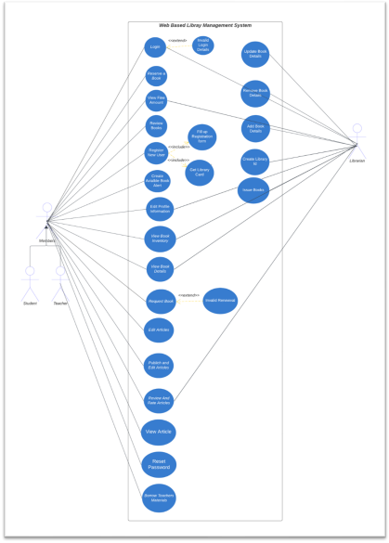12

**5.4.2 Activity Diagram**

We created several activity diagrams to demonstrate some of the major activities in our system.

**Login**

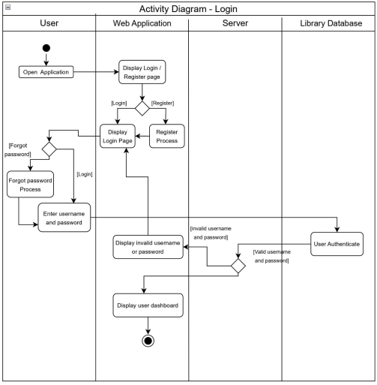13

**User Registration**

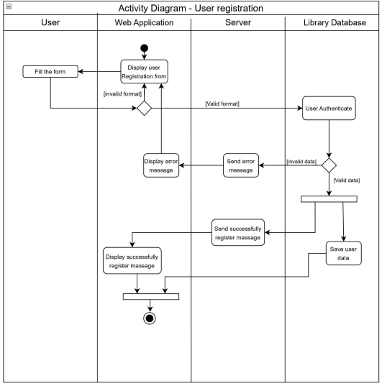14

**Forgot password.**

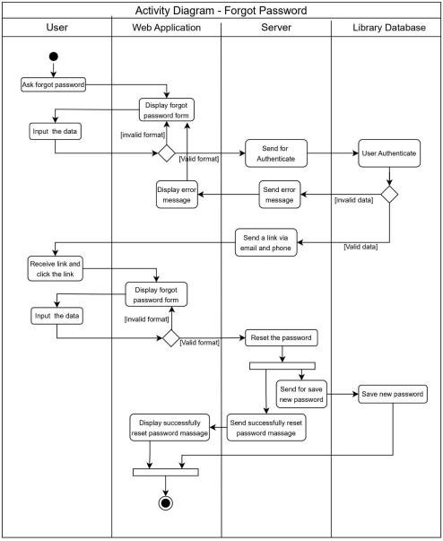15

**Edit user profile**

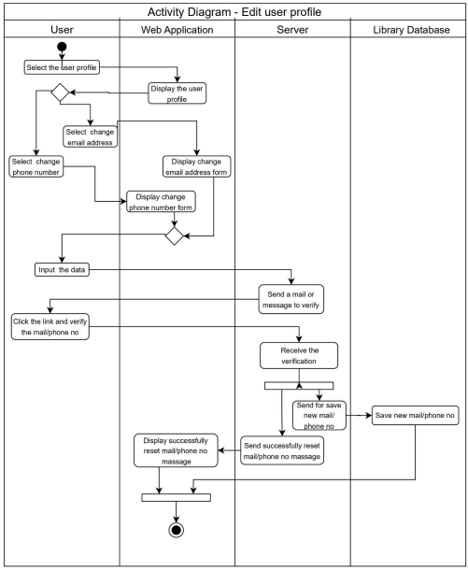16

**Submit articles**

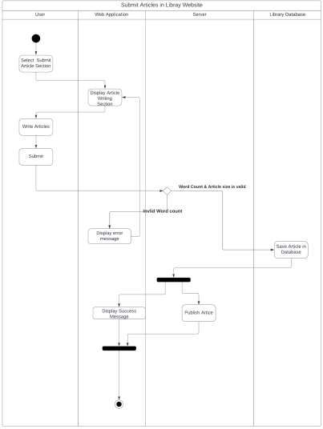17

**Edit submitted articles**

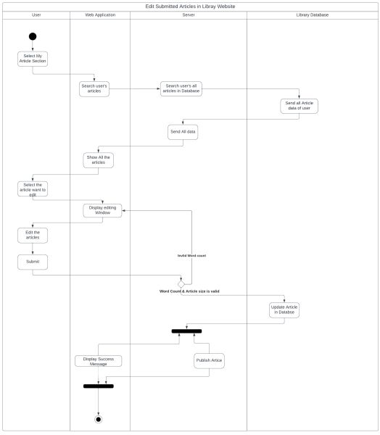18

**Delete Submitted articles**

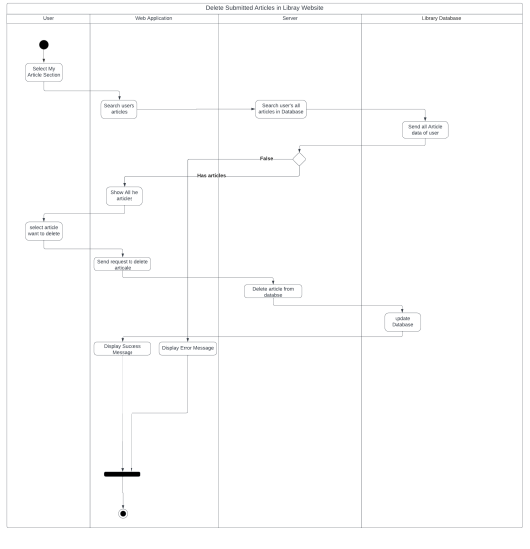19

**Librarian issue books**

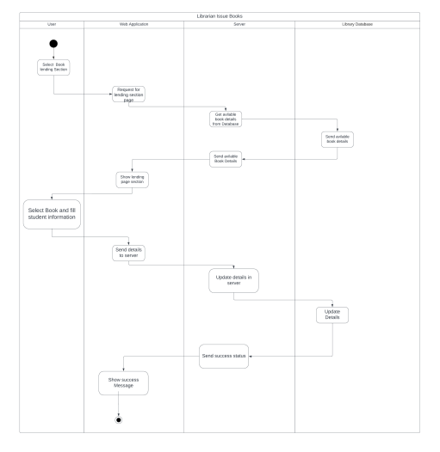20

**Create user id**

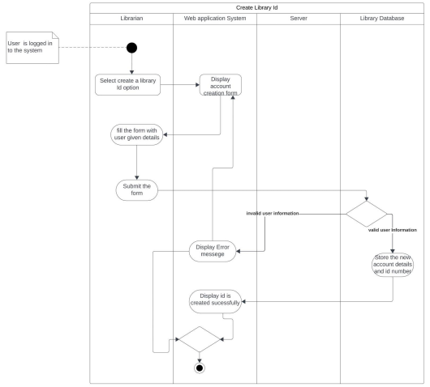21

**Add books**

****22

**Edit books**

****23

**Remove a book**

****24

**Display fine amount**

****25

**Rate article**

****26

**Reserve book**

****27

**review book**

****28

**view book inventory**

****29

**5.4.3 Sequence Diagram**

**Login**

****30

**User Registration**

****31

**forgot password**

****32

**Edit user profile**

****33

**submit articles**

****34

**edit submitted articles**

****35

**Delete Submitted articles**

****36

**Librarian issue books**

****37

**Create User ID**

****38

**Add Books**

****39

**Edit Books**

****40

**Remove a Book**

****41

**Display fine amount**

****42

**Rate Article**

****43

**Reserve a Book**

****44

**review book**

****45

**view book inventory**

****46

**5.4.5 Class Diagram**

****47

**5.4.5 EER Diagram**

****48

**5.5 Summary**

In this chapter, we have undertaken a comprehensive design and analysis of the core modules central to the Library Management System. The system is organized into five primary modules, each strategically developed to enhance specific aspects of the library management process. The User Authentication module ensures secure and personalized access, allowing librarians, students, and teachers to interact with the system according to their designated roles. The Order module streamlines book-related processes, including requests, lending, and returns, optimizing the overall borrowing experience. The Delivery module focuses on facilitating seamless resource accessibility, providing users with an efficient means of locating and retrieving books. The Adding and Updating module empower librarians to maintain an accurate and up-to-date book inventory, facilitating easy additions of new titles and updates to existing entries. Lastly, the Backhauling module ensures a holistic approach to library resource management, addressing elements such as book returns and warehouse operations. The upcoming chapter will delve into the practical implementation of these modules, shedding light on the execution of the proposed solution within the Library Management System.

49

**6. Implementation**

**6.1 Introduction**

The Library Management System is a sophisticated digital solution designed to streamline and enhance the operations of school libraries. This system caters to the specific needs of librarians, students, and teachers by providing a user-friendly platform that simplifies interactions with the library. Librarians benefit from extensive administrative features, allowing efficient management of the book inventory, user accounts, and the facilitation of borrowing teaching materials for educators. Students enjoy a simplified interface, granting them easy access to borrowing history, fine monitoring, and exploration of the book inventory. Additionally, the system promotes an interactive learning environment by allowing students and teachers to contribute articles, rate and review books, fostering knowledge exploration and collaboration. With features like user authentication, efficient order processing, and a dynamic article section, the Library Management System ensures a comprehensive and effective solution for modernizing the management of educational libraries.

**6.2 Implementation**

****50

**6.3 summary**

we have comprehensively detailed the implementations carried out thus far in the project. This section provides a detailed overview of the software applications utilized for the implementation of each module within the system. Emphasizing the interconnectedness of each module, we underscore how these interconnections synergize to deliver a seamless and effective user experience. The chapter serves as a comprehensive guide, outlining the intricate software usage employed in the implementation of individual modules, ultimately contributing to the overall success of the system and ensuring optimal functionality for end-users.

51

**7. Discussion**

**7.1 Introduction**

In the previous chapter, we discussed the implementation stage of our web-based library management system up to this point. In this chapter, our focus shifts towards evaluation and testing of our solution, specifically examining its impact on school library management. Additionally, we discuss future developments and enhancements in this chapter.

**7.2 Testing and Evaluation**

At this stage, we haven’t evaluated or testing our solution because we’re still in the early stages of development. In this chapter, we want to talk about what makes our solution unique compared to other library management system.

**7.3 How Our solution Differ from Other Solutions**

In this project, we’ve created a user-friendly environment to make it easy for library users. We have introduced a book reservation feature that allows user to reserve the books they want or need a day before borrowing. Additionally, users have the option to create their accounts, making the library experience more personalized and accessible for them. Here we have an article section to encourage users and enhance their writing skills. This section enables users to contribute their articles. These articles serve as a valuable resource for other library users, knowledge exchanging and information sharing within the library community.

**7.4 Summary**

Through the above paragraph, we have discussed the functions that we perform through our library management system application and how those functions differ from existing applications and future developments that expect to perform.

52

**8. References**

1) Spring boot: https://spring.io/guides/gs/spring-boot/ 2) React js: https://legacy.reactjs.org/docs/getting-started.html 3) Rest API: https://www.redhat.com/en/topics/api/what-is-a-rest-api 4) MySQL: https://dev.mysql.com/doc/

53

**9. Appendices**

**Appendix A. Individual Contribution**

**Paranietharan P.**

As a leader of this team, I am in charge of arranging meeting with mentors and supervisors, managing project tasks, divide the contributions among group members, coordinate knowledge sharing sessions and guide the group members to focus on their works. I successfully organized meeting with Our company mentor to know about our project requirements and learned about important things. I designed UI/UX frame work for article section. I contributed to drawing activity diagrams, sequence diagrams, use case diagram and class diagram. I will develop article section which is use to submit new articles, edit submitted articles, delete articles and rating article section. This section will help to give a dynamic platform for knowledge exchange and interaction among users.

**Lathisana T.**

I am responsible for developing the admin dashboard in this application which is use to view reserved and available book details, book lending process, user Id creation, book management and manage article section. I actively participated in the brainstorming sessions, supervisor meetings, mentors meeting and learned important things form these. I gave my contribution to design the activity and sequence diagram. I had a big challenge on how to design Admin dashboard So I learned about UI/UX frame works by using YouTube videos and tutorials. Then I make the design by using Figma. It provided me with a clear under-standing of my task and progress. These days I studying MySQL to design database. It is suitable for establishing relationship between tables and retrieving essential details. In future, I plan to learn React Native and spring Boot to further develop of our project

**Mihunan V.**

I am Responsible for book inventory which is helpful to Display all book detail in library with available status, rate books, Comments about book and book feed. I contributed to drawing activity and sequence diagrams. I designed UI/UX design for my individual contribution in Figma.

**Shobikan V.**

My focus within the project revolves around user authentication and account management. This includes the critical functionalities of login/sign-up, account creation, first-time login for librarian-created accounts, password recovery/forgot password, and user profile management. I played a key role in ensuring the secure and seamless user experience within the authentication and account management aspects of our library management system.

54

**Yasothan R.**

My responsibilities center around developing the user dashboard, ensuring a user-friendly experience. This includes displaying details of borrowed books, managing fines, implementing a robust search and filter functionality for books, handling user complaints and problem reporting, and facilitating notifications via email. These functionalities are crucial in providing users with an intuitive and efficient interface for their interactions within the library management system.

55

**Appendix B. Action Plan**

| **Task** | **D**  **u**  **r**  **a**  **t**  **i**  **o**  **n** | **Start date** | **Time Line** | | | | | | | | | | | | | | | | | | | |
| --- | --- | --- | --- | --- | --- | --- | --- | --- | --- | --- | --- | --- | --- | --- | --- | --- | --- | --- | --- | --- | --- | --- |
| **2024** | | | | | | | | | | | | | | | | | | | |
| **December** | | | | **January** | | | | **February** | | | | **March** | | | | **April** | | | |
|  | **1 2** | **3** | **4** | **1** | **2** | **3** | **4** | **1** | **2** | **3** | **4** | **1** | **2** | **3** | **4** | **1** | **2** | **3** | **4** |
| Interim Report Submission | **1** | **30/12/23** |  |  |  |  |  |  |  |  |  |  |  |  |  |  |  |  |  |  |  |  |
| Design the UI | **1** | **07/01/2023** |  |  |  |  |  |  |  |  |  |  |  |  |  |  |  |  |  |  |  |  |
| Defining the  endpoint | **1** | **14/01/2024** |  |  |  |  |  |  |  |  |  |  |  |  |  |  |  |  |  |  |  |  |
| Designing  Database | **1** | **21/01/2024** |  |  |  |  |  |  |  |  |  |  |  |  |  |  |  |  |  |  |  |  |
| Implement  business logic in the backend | **3** | **12/02/2024** |  |  |  |  |  |  |  |  |  |  |  |  |  |  |  |  |  |  |  |  |
| Create web  interface | **3** | **05/03/2024** |  |  |  |  |  |  |  |  |  |  |  |  |  |  |  |  |  |  |  |  |
| Connect frontend with backend | **1** | **12/03/2023** |  |  |  |  |  |  |  |  |  |  |  |  |  |  |  |  |  |  |  |  |

56

| Test in the dev environment | **2** | **26/03/2023** |  |  |  |  |  |  |  |  |  |  |  |  |  |  |  |  |  |  |  |  |
| --- | --- | --- | --- | --- | --- | --- | --- | --- | --- | --- | --- | --- | --- | --- | --- | --- | --- | --- | --- | --- | --- | --- |
| Initialize  deployment  environment | **2** | **09/042023** |  |  |  |  |  |  |  |  |  |  |  |  |  |  |  |  |  |  |  |  |
| Debugging the beta release | **2** | **21/04/2023** |  |  |  |  |  |  |  |  |  |  |  |  |  |  |  |  |  |  |  |  |
| Deploy final  product | **1** | **28/04/2023** |  |  |  |  |  |  |  |  |  |  |  |  |  |  |  |  |  |  |  |  |

57

**Appendix C. Mockups**

**Paranietharan P.**

 Figure 9.1 Mockups –Articles Home page

58

Figure 9.2 Mockups – Write new Article

59

60

Figure 9.3 Mockups – Read article

Figure 9.4 Mockups – search article

61

 Figure 9.5 Mockups – Article page profile

62

 Figure 9.6 Mockups – Article Search bar

63

**Shobikan V.**

****Figure 9.7 Mockups – user login

64

Figure 9.8 Mockups – new user registration

65

Figure 9.9 Mockups – verification page

66

Figure 9.10 Mockups – forgot password

67

Figure 9.11 Mockups – create new password

68

Figure 9.12 Mockups – create account 2nd step

69

Figure 9.13 Mockups - Create account success page

70

**Lathisana T.**

****Figure 9.14 Mockups – Admin dashboard home

71

Figure 9.15 Mockups – Admin dashboard

72

Figure 9.16 Mockups – Admin dashboard create new profile

73

Figure 9.17 Mockups – Admin dashboard article management

74

Figure 9.18 Mockups – Admin dashboard update user profile

75